MNIST Tanh:

Not normalized (images in 0-255):

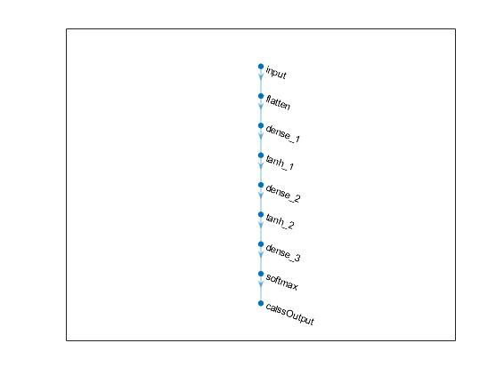

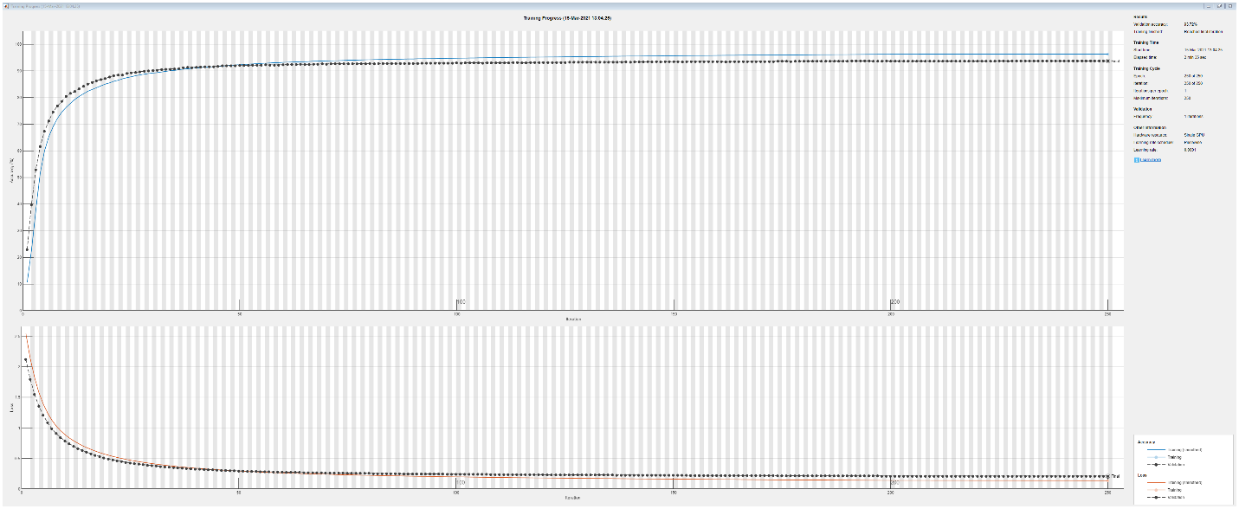

Validation accuracy: 93.72%

Test accuracy = 93.12%

MNIST Tanh:

Normalized (images in 0-1):



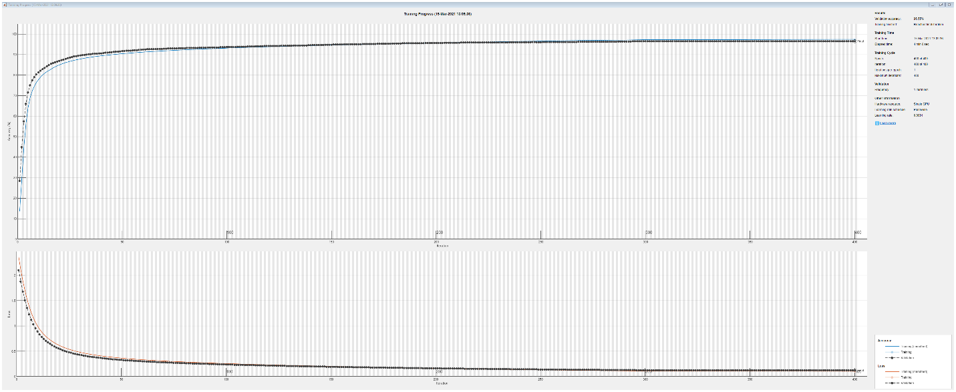

Validation accuracy: 96.55%

Test accuracy = 96.39%

